2022 Spring - Big Data Analytics Demissie

**Linux Lab #1.2**

**Note:** *Before completing this assignment please read/watch the following online resources:*

* The Linux Cookbook: Tips and Techniques for Everyday Use - Files and Directories.

(n.d.).

Retrieved from <http://dsl.org/cookbook/cookbook_8.html>

* Linux File system Hierarchy. (n.d.). Retrieved from <http://www.tldp.org/LDP/Linux-Filesystem-Hierarchy/html/c23.html>

* *Linux Filesystem Hierarchy - Part One* [Video file]. (n.d.). Retrieved from <https://www.youtube.com/watch?v=460IxkYmZxQ>

* *Linux Filesystem Hierarchy - Part Two* [Video file]. (n.d.). Retrieved from

<https://www.youtube.com/watch?v=WMaWG5ZRht4>

Now first move to your home directory ***cd ..***and then as shown in the fig below, and to create a script file type the following at the command prompt :

***$ script* Linux Lab #3**  ( hit enter) *and answer the following questions at the command prompt*:

1. Go to the parent directory of the current directory.
2. Go to the root directory.
3. List a long listing of the root directory.
4. Stay where you are, and list the contents of /etc.

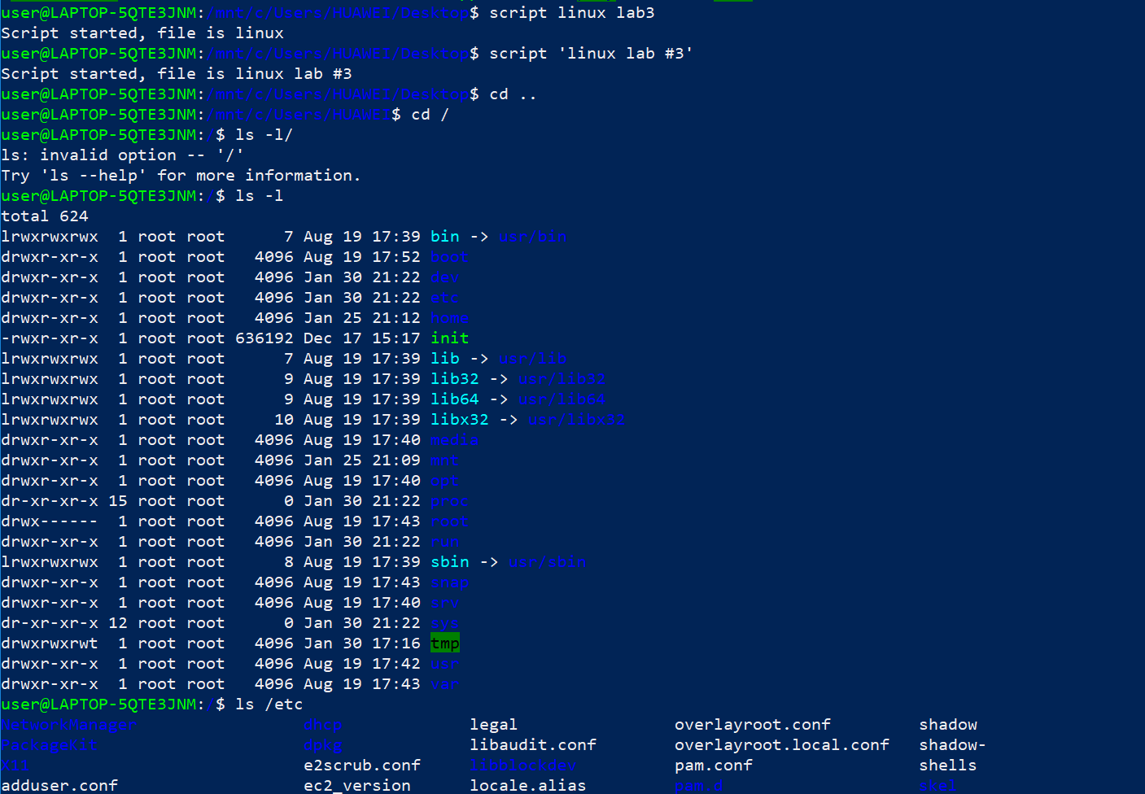

1. Stay where you are, and list the contents of /**bin and /sbin.**

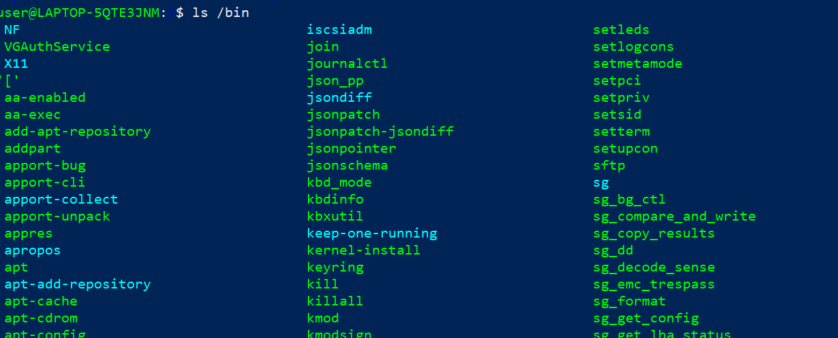

1. Stay where you are, and list the contents of **~**.
2. List all the files (including hidden files) in your home directory.

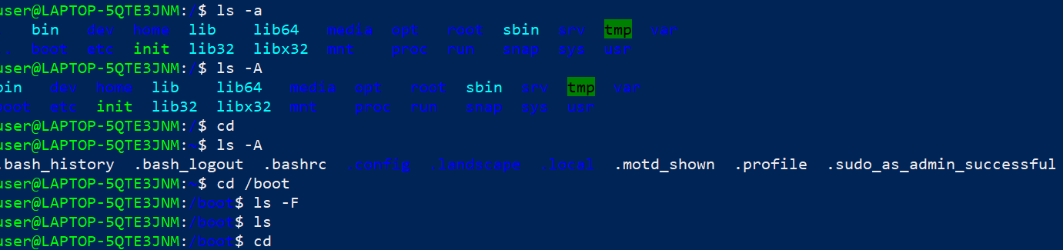

1. List the files in **/boot** in a human readable format.

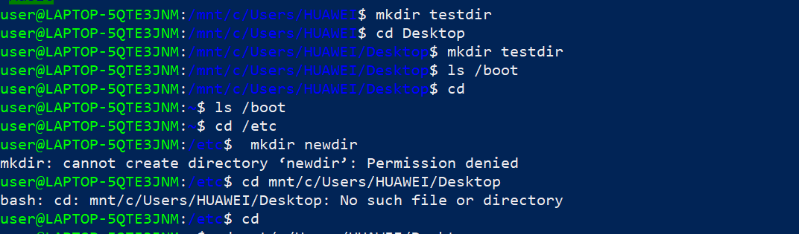

1. Create a directory testdir in your home directory.
2. Change to the **/etc** directory, stay here and create a directory newdir in your home directory.
3. Create in one command the directories **~/dir1/dir2/dir3** (dir3 is a subdirectory from dir2, and dir2 is a subdirectory from dir1 ).

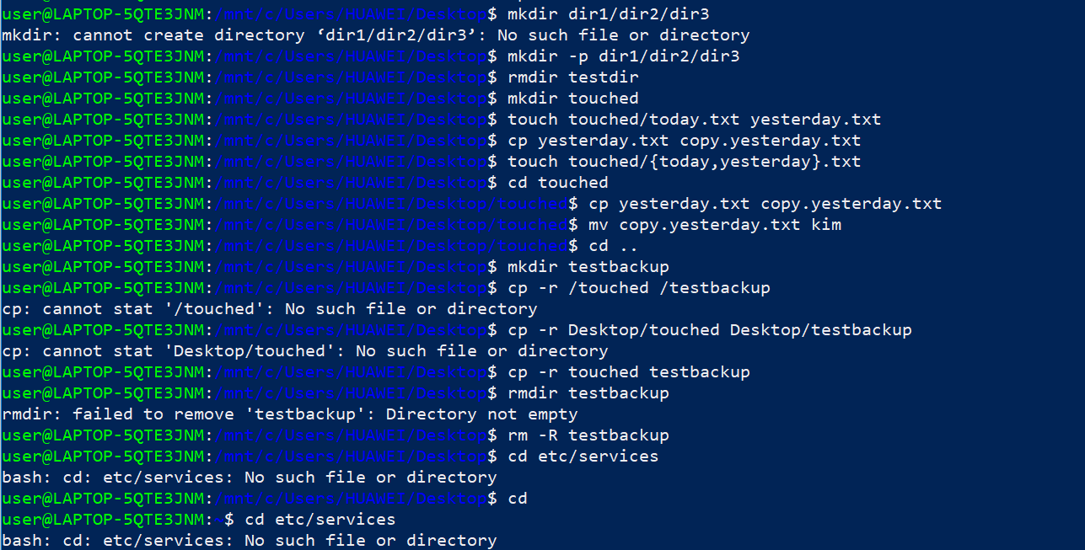

1. Remove the directory testdir.

2021 Spring - Big Data Analytics Demissie

1. Create a directory **~/touched** and enter it.
2. Create the files today.txt and yesterday.txt in touched.
3. Copy yesterday.txt to copy.yesterday.txt
4. Rename copy.yesterday.txt to kim
5. Create a directory called **~/testbackup** and copy all files from ~/touched into it.
6. Use one command to remove the directory ~/testbackup and all files into it.
7. Display the first 12 lines of **/etc/services**.

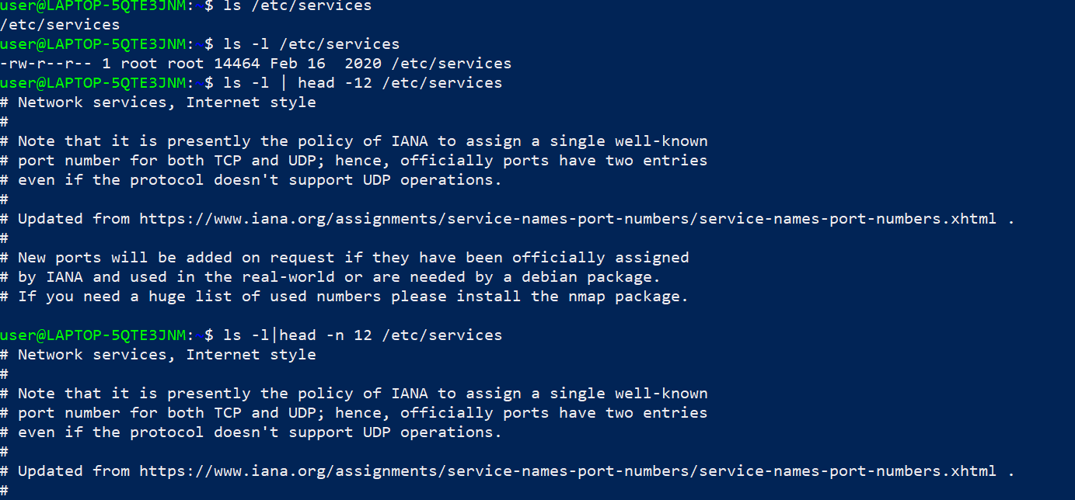

1. Display the last line of **/etc/passwd**.

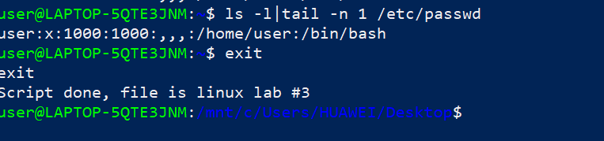

**To stop the script file… simple type *exit* at the command prompt.**